MOBILE COMPUTING
Progress File

Course Instructor:
Professor Haq Nawaz

Written and Managed By:
Muhammad Hasnain
(BSEF18A012)

Punjab University College of Information Technology
University of The Punjab

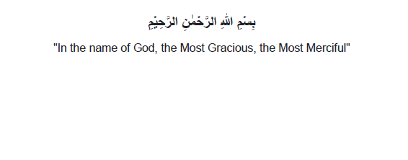



Version Control Systems
What will we learn?
• Version Control Systems
• Concepts like Online Editing and Merge Conflicts
• Different cmd commands
git-add
git-commit
git-status
git-push
git-pull
git-log
git rm
git-branch
git-checkout
git-merge
(Note: Don’t panic! You can do it easily.)
It is wriiten in quran:
“Allah does not charge a soul except [with that within] its capacity.”
Surah: Al-Baqara Ayah: 286
Version Control Systems:
What is VCS:
Version control is a system that records changes to a file or set of files over time so
that you can recall specific versions later. Using a VCS also generally means that if
you screw things up or lose files, you can easily recover.
Why do we need it:
▪ To keep track of changed to code.
▪ To make same code available to all members working on a project.
▪ To synchronize code between groups.
▪ To test changes without losing original files.
▪ To revert back to old version.
Now we know about the VCS. Lets practically dive into it. But, before starting kindly
understand that these notes are made in step by step format. Steps with screenshots
are attached with proper explanation. Just follow the steps and you will get everything
done.
Having said that Buckle up!

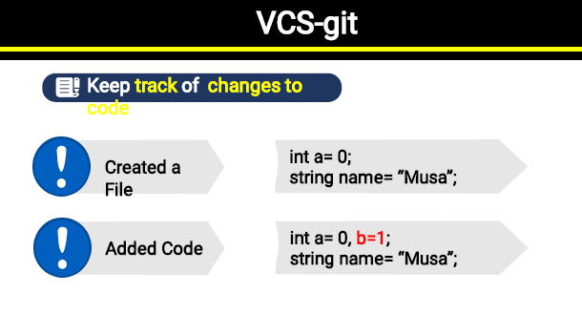
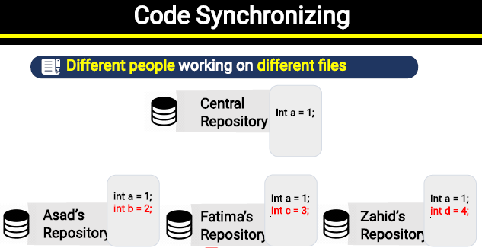


New at GitHub:
Follow these Streps:-
- Go to github website (https://github.com/) and sign for free.

- Make a new repository.
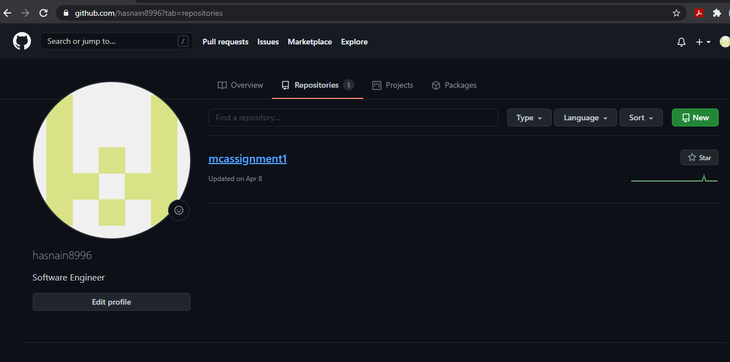

- Give it a meaningful name. I am giving “MC_Progress”.
- Copy repository link. We need it in coming steps.
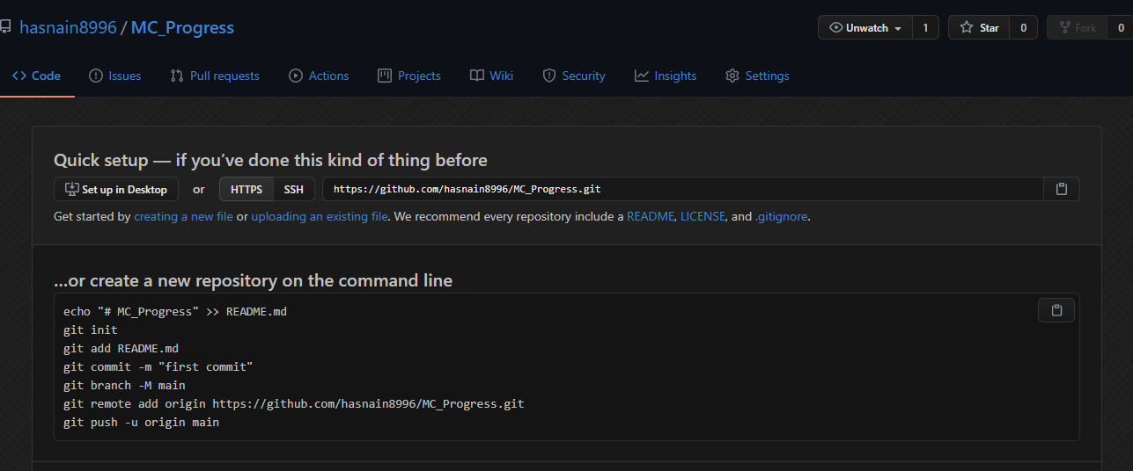

5. You must install git in you machine. Type “git install” on google. Download and
install it.

6. Now make a folder named as git.

7. Now open cmd (run as administator)
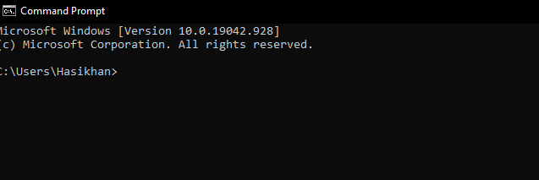

8. Use cd command and go to desired directory.
9. Write “git clone [parameter i.e url]”. Paste the link in place of parameter you
previously coppied.
10. You will observe a folder automatically got created with the name of the repository.

Android Studio
Install and setup android studio. Make an empty project project. A “Hello
World” mobile application will be made by defualt. Following is screenshots
of android app I tried to make with very basic knowledge just to set up the
pace and become familiar with the interface.

Intent
An Intent is a messaging object you can use to request an action from
another app component.
There are two types of intents:
• Explicit intents specify which application will satisfy the intent, by
supplying either the target app's package name or a fully-qualified
component class name. You'll typically use an explicit intent to start a
component in your own app, because you know the class name of
the activity or service you want to start. For example, you might start
a new activity within your app in response to a user action, or start a
service to download a file in the background.
• Implicit intents do not name a specific component, but instead
declare a general action to perform, which allows a component from
another app to handle it. For example, if you want to show the user a
location on a map, you can use an implicit intent to request that
another capable app show a specified location on a map.
Following Screenshot shows the coding of both Intents:
Impilicit Intent:

In Picture Above I have made Functions(methods) which acts with onClick
function.
Google, Call and Github funtions are examples how we can make implicit
intents.

Look at picture below When I touch Google Icon it asks me which App do I
want to use to perform the action.

Animations
Now we see that how to animate elements in android studio. Here we will go through the property of creating Anim.resource file and then creating animation.xml file

Here we will select the anim value for purpose

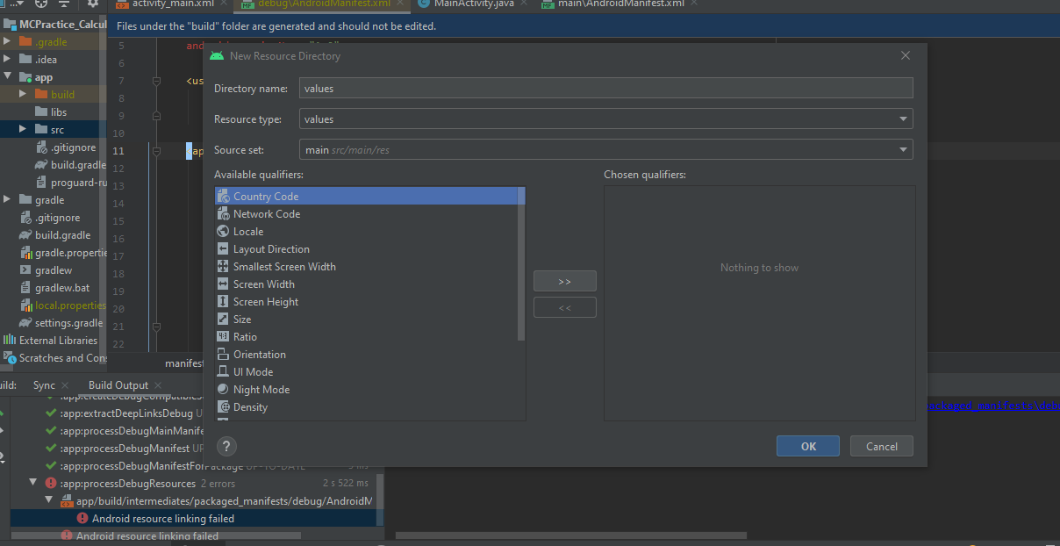

SqLite DataBase

We made an interface in which we have two input text boxes, one for name
and second for age and one switch which tells either the user is active or
not, two buttons (add record and view record) and delete button and delete
input box. Shown in figure below:

We want to store data we enter in a database so we will make a Customer
class in our application
It has variables, name ,age , isActive and id.
We used system function “Generate” to make getters and setters of all the
variables, We also made constructor for the class. All these coding is
displayed in picture below. Please do refer to it.

Create a DBHelper class which will have functions which add and delete
out data into database. Implementation is shown in images below.

We will use these functions in our MainActivity to make our app complete.

